# Gardiners Creek Reserve – Fieldwork Data

# Task 2 Processing and analysing data Student Worksheet

## Introduction

When carrying out investigations and experiments, scientists collect data in the form of observations and measurements. To make sense of this data and to see any patterns in the data, scientists process it. That is, they reorder the data, make calculations and create visual representations of the data. This not only helps them make sense of the data, it also helps them communicate information and ideas to other people. In this task, you will process the fieldwork data collected by scientists at Gardiners Creek Reserve.

The fieldwork data is presented in spreadsheets. It shows the names of organisms found and the number or each type of organism found in each of nine pitfall traps in the two different environments. To make this data useful it is first necessary to conveniently group (collate) the data. Then the collated data needs to be presented in graphical form. You may use MS Excel to process the data and create graphs electronically or the work can be done by hand.

The aim of this analysis is to compare the types and numbers of organisms found at the two different sites. If the survey is repeated at a later time, a comparison can be made between the data collected initially and that collected later. Such a comparison may indicate changes that are occurring in the environment and may be used to make decisions about how the Reserve can be best managed.

## Instructions

1. Count the total number of organisms of each type found at each Site (Grassy Woodland and Leafy Woodland)

For example, a total of 5 Coleoptera (beetles) were found in the Grassy Woodland.



1. Create a new table in Excel that shows just the name of the organism and the total number or record the totals in the table below.

|  |  |  |
| --- | --- | --- |
| **Scientific name** | **Common name** | **Grassy woodland** |
|  | Total number invertebrates |  |
| **INSECTA: Sub-class: Pterygota** | Total Insects |  |
| **Coleoptera** |  |  |
| **Collembola** |  |  |
| **Dermaptera** |  |  |
| **Diptera** |  |  |
| **Hymenoptera** |  |  |
| **Lepidoptera** |  |  |
| **Orthoptera** |  |  |
| **ARACHNIDA** |  |  |
| **CRUSTACEA** |  |  |
| **GASTROPODA** |  |  |
| **HIRUDINEA** |  |  |
| **OLIGOCHAETA** |  |  |
| **MYRIAPODA** |  |  |

|  |  |  |
| --- | --- | --- |
| **Scientific name** | **Common name** | **Leafy woodland** |
|  | Total number invertebrates |  |
| **INSECTA: Sub-class: Pterygota** | Total Insects |  |
| **Coleoptera** |  |  |
| **Collembola** |  |  |
| **Dermaptera** |  |  |
| **Diptera** |  |  |
| **Hymenoptera** |  |  |
| **Lepidoptera** |  |  |
| **Orthoptera** |  |  |
| **ARACHNIDA** |  |  |
| **CRUSTACEA** |  |  |
| **GASTROPODA** |  |  |
| **HIRUDINEA** |  |  |
| **OLIGOCHAETA** |  |  |
| **MYRIAPODA** |  |  |

1. Create a bar chart for each site showing the types or organisms and the numbers of each. Also show the total number of invertebrates and the Total number of Insects (as well as the numbers of each Order of insects). The graph below shows a part of the final bar chart you should produce.

To create the bar chart in Excel, highlight the cells that contain the data you wish to appear in the chart (this will be the two columns and the rows that contain the names and numbers). Then from the insert tab select bar chart or column chart. Excel will produce a chart for you.



If you are not using Excel you need to draw your bar chart by hand. The length the bars corresponds to the number of organisms.

1. Now create a bar chart that shows a comparison between each site. In Excel highlight the rows and columns containing the information you want to graph. Under the insert tab select.

In Excel you would highlight all of these cells.

|  |  |  |
| --- | --- | --- |
|  | **Grassy woodland** | **Leafy Woodland** |
| **INVERTEBRATES** |  |  |
| **INSECTA: Sub-class: Pterygota** |  |  |
| **Coleoptera** |  |  |
| **Collembola** |  |  |
| **Dermaptera** |  |  |
| **Diptera** |  |  |
| **Hymenoptera** |  |  |
| **Lepidoptera** |  |  |
| **Orthoptera** |  |  |
| **ARACHNIDA** |  |  |
| **CRUSTACEA** |  |  |
| **GASTROPODA** |  |  |
| **HIRUDINEA** |  |  |
| **OLIGOCHAETA** |  |  |
| **MYRIAPODA** |  |  |
| **TURBELLARIA** |  |  |

The result is a chart that looks something like this. Note the graph has a Legend indicating the environment to which each bar belongs.

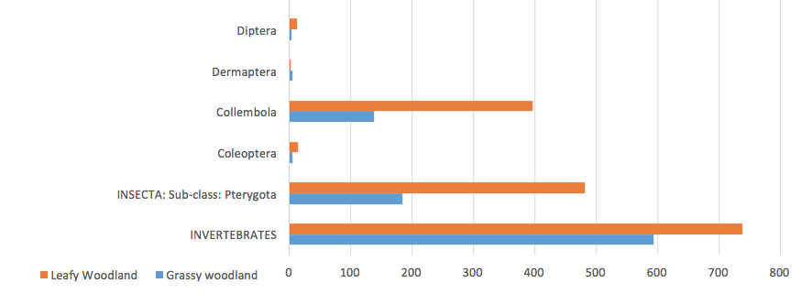

1. To compare the proportions of the types of organisms in each environment you can use a pie chart. In Excel highlight the cells and under the Insert tab



## Questions

1. What are the advantages and disadvantages of each of the graphs (charts) you have drawn?

Using your processed data and charts answer the following questions.

1. Which environment has the greatest number of organisms? Justify your answer with evidence?
2. Which environment has the greatest number of different organisms i.e. the greatest diversity? Justify your answer with evidence?
3. How do the number of insects compare between the two environments?
4. After insects, which is the most abundant type or organism found in each environment?
5. a. Which organism shows the greatest difference in abundance between the two environments?
6. Account for the difference in the number of organisms you have named in 6a. above.